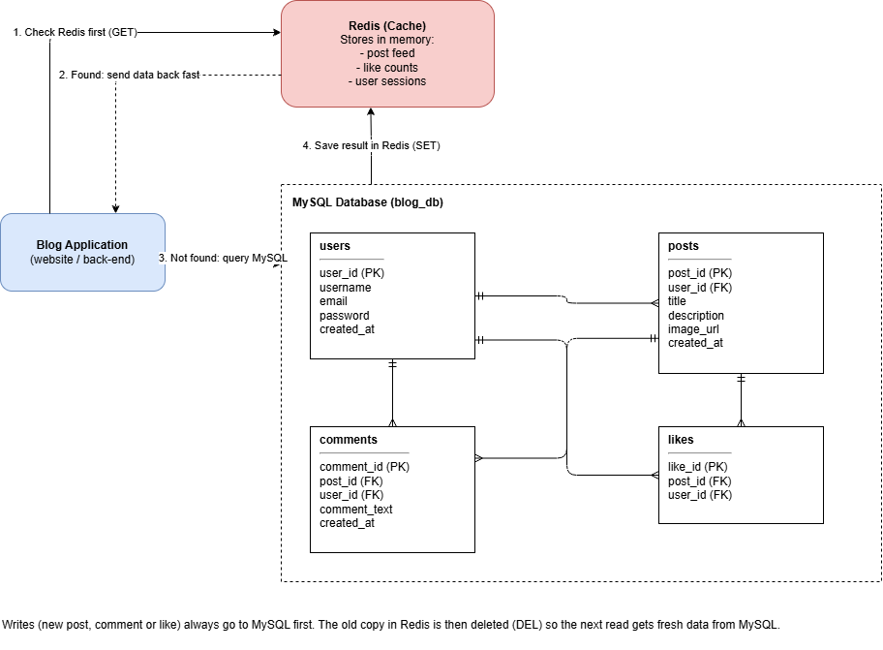
Exercise 4 – Adding Redis to the Blogging System
I added Redis to my Exercise 1 diagram as a cache that sits between the blog application and the MySQL database. Redis keeps data in memory, so it is much faster to read than the database.
When the app needs data, like the list of posts or the number of likes on a post, it checks Redis first. If the data is in Redis, it is sent straight back to the app. If it is not in Redis, the app gets it from MySQL and then saves a copy in Redis so the next request is faster.
MySQL is still the main database and keeps all the permanent data. When a user creates a post, adds a comment, or likes a post, the change is saved in MySQL first. The old copy in Redis is then deleted so users do not see out-of-date information.
I chose to cache the post feed, like counts, and user sessions because these are read very often and change less than they are viewed.

- Redis works with MySQL, it doesn’t replace it. Slide 79 says Redis is designed to work with a DBMS, not replace one.
- Redis is for fast reads, MySQL for permanent storage. This matches the slide 79 comparison table.
- Deleting the cache after a write is a standard pattern. It’s called “cache-aside.”

